Scenario
You are a security professional at a large organization. You mainly work with their research team. Part of your job is to ensure users on this team are authorized with the appropriate permissions. This helps keep the system secure.
Your task is to examine existing permissions on the file system. You’ll need to determine if the permissions match the authorization that should be given. If they do not match, you’ll need to modify the permissions to authorize the appropriate users and remove any unauthorized access.

Project description
In this project, I worked as a cybersecurity professional responsible for validating and managing file system permissions for a research team. Using Linux command-line tools, I inspected existing file and directory permissions, ensured they matched organizational security policies, and corrected any unauthorized access. This work was critical in maintaining confidentiality, integrity and access control within the system.

Check file and directory details
To inspect file permissions i used the “ls” in the “projects” directory :
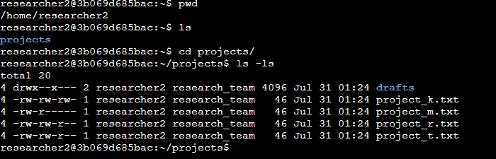
This command revealed the permissions, ownerships and visibility of all contect in the “project” directory.

Describe the permissions string
Let’s take the second string of “project_k.txt” to describe its permission string: -rw-rw-rw-
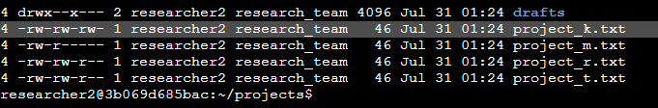
- The “-” means it is a regular file. If it were a “d” it would mean it's a directory like in the first string.
- The first“rw-” means the user has read and write but no execution permissions.
- The second set of “rw-” means the group has read and write but no execution permissions.
- The last set of “rw-” means others have read and write but no execution permissions.
This string in particular, indicates that everyone,including users outside the research group, can modify the file -which violates the organization’s security policy.

Change file permissions
To remove write access from “others” for the “project_k.txt”, i used the following command chmod o-w project_k.txt
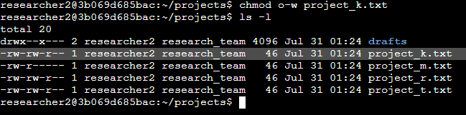
This command ensures only the user and group can write to the file, aligning with the organization’s restriction on write access for others.

Change file permissions on a hidden file
To be able to inspect file permission on hidden files i used the “ls - la” command
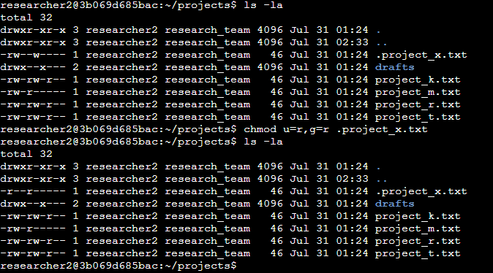
With this we can see that the file “.project_x.txt” is archived and hidden. It must be readable only by the user and group, with no write permission for anyone. So i applied the command chmod u=r,g=r .project_x.txt
With this command it is restricted write access entirely and grants read-only access to the owner and group, securing the file as required.

Change directory permissions
Inspecting the file and directories permissions with the “ls-l” command we found that the “drafts” directory originally had the permissions drwx- -x- - -
This means the user had full access and the group had execution permission.
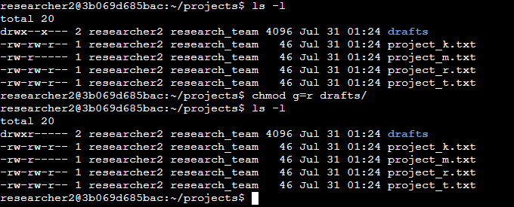
To restrict the execution only to the owner(user) i used the chmod g=r drafts/
This change ensures that only the user can access, modify or list contents in the directory, and the group only has reading permissions.

Summary
Throughout this project, I used essential Linux commands to secure the file system by analysing and modifying file and directory permissions. Using ls-la, I audited existing permissions, and with chmod, I enforced stricter access controls to meet organizational policies. This activity strengthened my ability to interpret permissions strings, manage hidden files and enforce secure defaults - all crucial skills for any cybersecurity role involving Linux systems.

